Introduction
The purpose of this project was to build an Web Application with RESTful API using Spring Boot Framework. In addition there is an authentication mechanism used to authenticate each request made by these APIs. This kind of mechanism is :

- Token-Based authentication

The library used for this function is

- jose4j

Application Manual
Application is uploaded on GitHub in the following link: https://github.com/IrdiCaushi/AppV1 where you can download it as a .zip file. Programs that we will need to successfully run this application are:

MongoDB – for database

IntelliJ or any other environment

Postman – for testing APIs

1-MongoDB Database

a) Installation on Ubuntu

$ sudo apt-key adv --keyserver hkp://keyserver.ubuntu.com:80 –recv
9DA31620334BD75D9DCB49F368818C72E52529D4

$ echo "deb [ arch=amd64 ] https://repo.mongodb.org/apt/ubuntu bionic/mongodb-org/4.0 multiverse" | sudo tee /etc/apt/sources.list.d/mongodb-org-4.0.list

$ sudo apt-get update

$ sudo apt-get install -y mongodb-org

$ mongo

b) Installation on Windows

https://docs.mongodb.com/manual/tutorial/install-mongodb-on-windows/

c) Using Terminal / GitBash

$ sudo service mongod start

$ mongo

> use books

> db.createCollection(“library”)

> db.collection.insert(
{
"title" : "title",
"genre" : "genre",
"author" : "author"
"pages" : "pages"
}

d) Install Git

$ sudo apt-get install git
or
git-scm.com/downloads

e) Clone repository into you computer

> git clone https://github.com/IrdiCaushi/AppV1.git

f) Import the project to IntelliJ

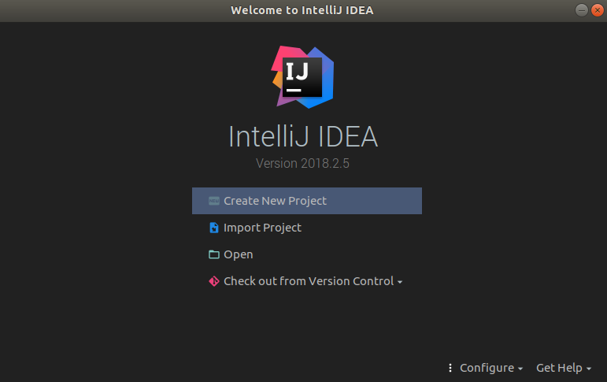

g) Select Maven as below

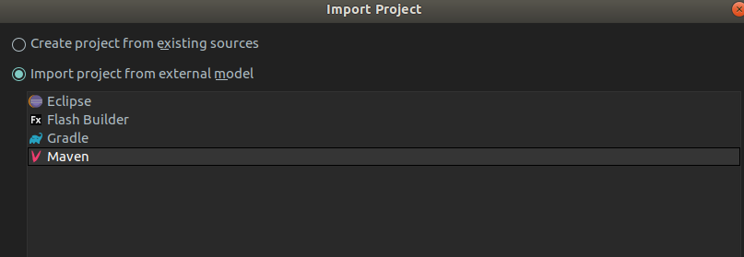
h) Select SDK Version

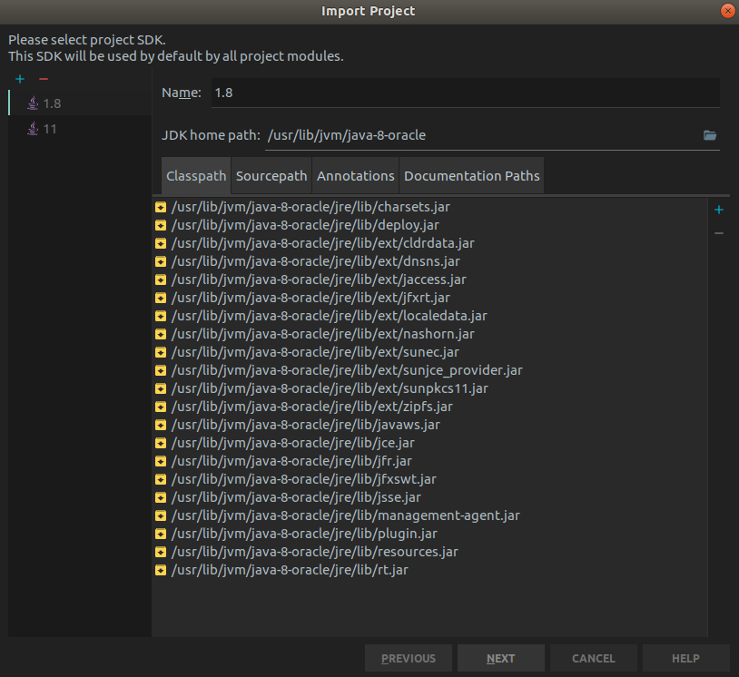

I) Import JSON file into Postman, where the methods are.

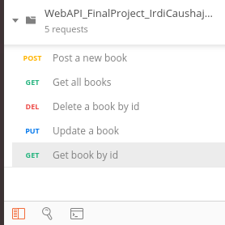

API Documentation

There are five methods used in this project as described below:

path: https://localhost:8443/library

=Get All Books

- Request
GET /library HTTP/1.1
Authorization: Bearer <token>

- Response
200 OK
Content-type: application/json
{
"library": [{

"_id": "ObjetId",
"title": "string",
"genre": "string",
"author": "string",
"pages": int

}, …]}

= Get Book by ID

- Request
GET /library/{id} HTTP/1.1
Authorization: Bearer <token>

- Response
200 OK
Content-type: application/json
{
"_id": "ObjetId",
"title": "string",
"genre": "string",
"author": "string",
"pages": int
}

= Post a new book

- Request
POST /library HTTP/1.1
Authorization: Bearer <token>

Content-type: application/json
{
// no ID included
"title": "string",
"genre": "string",
"author": "string",
"pages": int
}

- Response
201 Created
Content-type: application/json
{
"_id": "ObjetId",
"title": "string",
"genre": "string",
"author": "string",
"pages": int
}

= Update a book

Request

PUT /library/{id} HTTP/1.1
Authorization: Bearer <token>
Content-type: application/json
{
"title": "string",
"genre": "string",
"author": "string",
"pages": int
}

- Response
200 OK
Content-type: application/json
{
"_id": "ObjetId",
"title": "string",
"genre": "string",
"author": "string",
"pages": int
}

= Delete a book

- Request
DELETE /library/{id} HTTP/1.1
Authorization: Bearer <token>

- Response
204 No Content

Get request example taken from Java Application

> GET https://localhost:8443/library
> accept: */*
> accept-encoding: gzip, deflate
> authorization: Bearer <token>
> cache-control: no-cache
> connection: keep-alive
> content-type: application/json
> host: localhost:8443
> postman-token: 169b090b-e3cb-49aa-ba04-eacd1c800f01
> user-agent: PostmanRuntime/7.3.0

JWT Token validation is done by the jose4j library that we used, imported in AuthorizationFilter.java file in our application. This file has class implementation and all the checking needed to validate the token and request/response.

